**2.0 Conceptual Background**

Innovation in an OSS platform is driven by communities of external developers and end-users who contribute their expertise not only to develop the platform, and but also to develop its potential complements, which in turn, could spur platform diffusion.

Slide 2-3 of the presentation: Titles Open Source and USG

Distributed innovation system

Driven by volunteers (highly Digital Internet based)

Participation (intrinsic, extrinsic factors)

Role of the Community in open source (no or limited central control, rating,)

Distributed Innovation (License, transparency, quick release)

Network Effects (direct indirect)

**2.1 Effects of End-User Ratings**

*H1a: User Rating*

*H1b: Observational Learning*

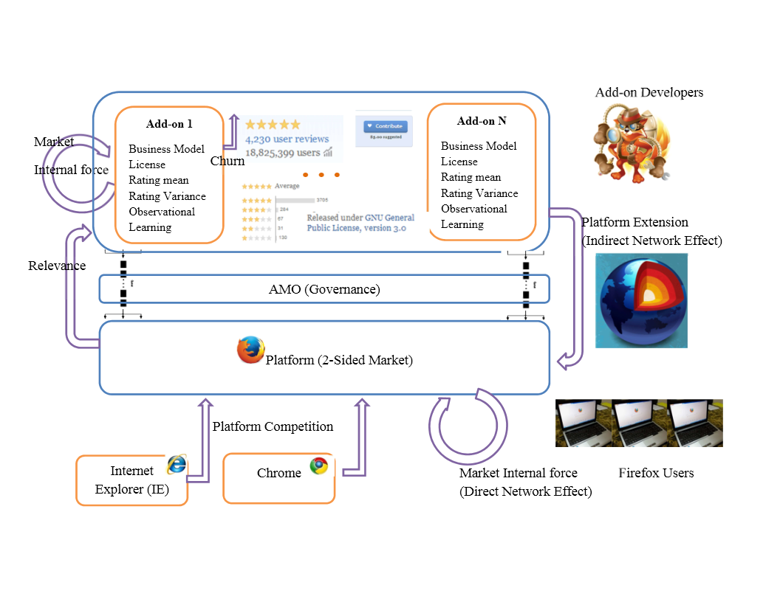

**2.2 Release Strategy**

*H2: Effect of Platform and Add-on versions*

**2.3 Third-party self-governance (AMO)**

*H3: AMO editor contributions*

**2.4 Network Externality**

*H4: Complement expands platform market*

**2.5 Platform Competition**

*H5: Complements and Substitutes*

**\*Add hypothesis and simplify above figure**